

**ORGANIZED BY**

**SUPPORTED BY**



**FROM 20TH TO 30TH OF SEPTEMBER**



COLLECT OVER 1,000,000 CIGARETTE BUTTS



COMPANIES, SCHOOLS, CITIES, TOWNS...

ALONE OR IN TEAM

BRING EMPTY RECYCLED PET BOTTLES AND GLOVES

REGISTER YOUR COLLECTION ON [WWW.WATERLOVER.ORG](http://WWW.WATERLOVER.ORG/)

HOW TO PARTICIPATE

FROM SEPTEMBER 20 TO 30, 2025

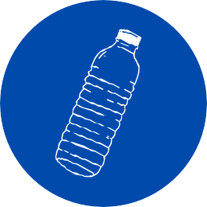

# STEP 1 STEP 2

WEAR A PAIR OF GLOVES TO PROTECT YOUR HANDS

RECYCLE EMPTY PET BOTTLES TO COLLECT CIGARETTE BUTTS

 

# STEP 3

COLLECT CIGARETTE BUTTS WITH FRIENDS, FAMILY, COLLEAGUES, ETC.

# STEP 4

NO MATTER WHERE IN THE WORLD, IN THE CITY, IN THE FOREST, BY THE LAKE, ... ANYWHERE! ALONE OR WITH OTHERS

 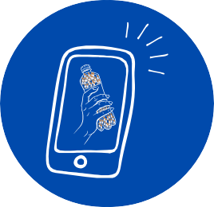

# STEP 5

NO NEED TO COUNT: A 0.5L BOTTLE = 250 BUTTS, 1L = 500 BUTTS, 1.5L. = 750 BUTS

# STEP 6

TO VALIDATE THE COLLECTION, JUST FILL OUT THE FORM AND TAKE A PHOTO OF THE COLLECTED BUTTS